Team Members

Name | Microservice 1 | Microservice 2
Mohoshena Akhter | Event Management Service | Venue Management Service
Debotush Dam | User Service | Ticketing Service
Md Parves Shikder | Booking Service | Payment Service
Muhammad Afaq Ali Saqib | Attendee Check-in Service | Reporting & Analytics Service

1. Complete System Architecture

The system contains the 8 microservices, all implemented in the project. An API Gateway is added as a shared integration component owned by the team to provide a single entry point, route requests and validate JWTs.

1.1 Services and Responsibilities

Service | Main Responsibility | Owner
Event Management Service | Create, update, schedule, publish, cancel and complete events. | Mohoshena
Venue Management Service | Manage venues, seating layouts, capacity and availability. | Mohoshena
User Service | Registration, authentication, profiles and roles. | Debotush
Ticketing Service | Ticket types, pricing, inventory and QR codes. | Debotush
Booking Service | Reservations and booking lifecycle. | Parves
Payment Service | Payment processing, transactions and refunds. | Parves
Attendee Check-in Service | Ticket validation at entry, attendance tracking. | Afaq
Reporting & Analytics Service | Sales, revenue and attendance reports. | Afaq
API Gateway | Entry point, JWT validation, routing, load balancing. | Shared

1.2 Relationships Between Services

- Event depends on Venue.
- Ticketing depends on Event.
- Booking depends on Ticketing and Payment.
- Check-in depends on Ticketing and Event.
- Reporting consumes events from Booking, Payment and Check-in.
- All services rely on User Service for authentication.

1.3 Architecture Diagram

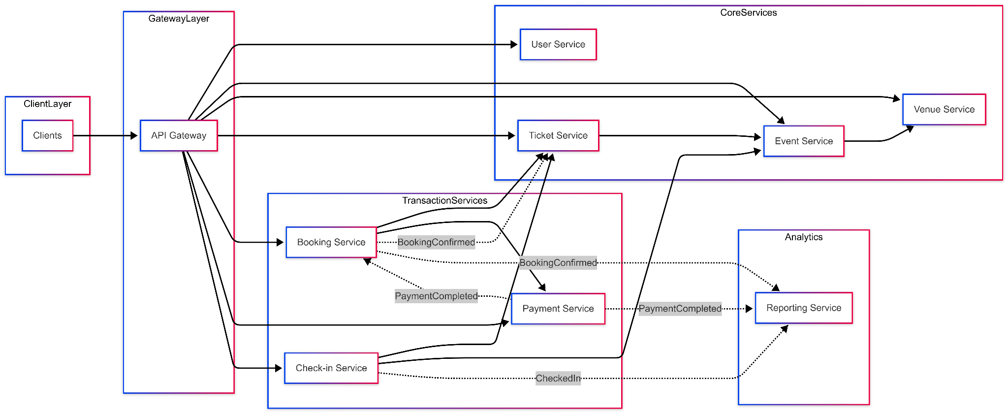

2. Service APIs

2.1 Event Management Service

Endpoint | Method | Description
/events | POST | Create a new event
/events | GET | List events (browse).
/events/{id} | GET | Retrieve event details.
/events/{id} | PUT | Update event details.
/events/{id}/status | PATCH | Publish, cancel or complete the event.
/events/{id}/venue | PUT | Assign a venue to the event.

2.2 Venue Management Service

Endpoint | Method | Description
/venues | POST | Create a new venue.
/venues | GET | List venues.
/venues/{id} | GET | Retrieve venue details.
/venues/{id} | PUT | Update venue information.
/venues/{id}/availability | GET | Check availability for a date range.

2.3 User Service

Endpoint | Method | Description
/users/register | POST | Register a new user
/users/login | POST | Authenticate and return JWT.
/users/{id} | GET | Retrieve user profile.
/users/{id} | PUT | Update profile.
/users/{id}/role | PATCH | Assign or change role (admin).
/users/validate | POST | Validate a JWT (used by API Gateway).

2.4 Ticketing Service

Endpoint | Method | Description
/events/{eventId}/tickettypes | POST | Create ticket types.
/events/{eventId}/tickettypes | GET | List available tickets for an event.
/ticket-types/{id}/reserve | PATCH | Reserve N units (called by Booking).
/ticket-types/{id}/release | PATCH | Release N units on cancellation.
/tickets/{id}/status | GET | Return ticket validation status (used by Check-in).
/tickets | POST | Issue a ticket with QR code after booking confirmation

2.5 Booking Service

Endpoint | Method | Description
/bookings | POST | Create a booking and reserve tickets.
/bookings/{id} | GET | Retrieve booking details.
/bookings/{id} | DELETE | Cancel a booking.
/bookings/{id}/pay | POST | Initiate payment for the booking.
/users/{userId}/bookings | GET | List a user's bookings

2.6 Payment Service

Endpoint | Method | Description
/payments | POST | Create a payment for a booking.
/payments/{id} | GET | Retrieve payment details.
/payments/{id}/process | POST | Process payment and publish PaymentCompleted event.
/payments/{id}/refund | POST | Refund a payment.
/bookings/{bookingId}/payment | GET | Get payment by booking.

2.7 Attendee Check-in Service
​​
Endpoint | Method | Description
/checkins | POST | Validate scanned ticket and perform attendee check-in.
/checkins/{id} | GET | Retrieve a specific check-in record.
/checkins/tickets/{ticketId} | GET | Get check-in status for a ticket.
/events/{eventId}/checkins | GET | List all check-ins for an event.
/events/{eventId}/attendance | GET | Return current attendee count for an event.
/checkins/{id}/reverse | PATCH | Reverse an incorrect check-in by staff/admin.

2.8 Reporting & Analytics Service

Endpoint | Method | Description
/reports/events/{eventId}/sales | GET | Generate ticket sales report for an event.
/reports/events/{eventId}/revenue | GET | Generate revenue summary for an event.
/reports/events/{eventId}/attendance | GET | Generate attendance statistics for an event.
/reports/events/{eventId}/categories | GET | Show ticket category performance metrics.
/reports/events/{eventId}/utilization | GET | Generate venue utilization report.
/reports/dashboard | GET | Return overall business dashboard metrics.

2.9 API Gateway (Team)

Single entry point for clients. Validates JWTs (via User Service /users/validate), routes requests to the correct service, and load-balances across instances. No business endpoints of its own.

3. Service Data Models

Each service owns its own database.

3.1 Event Service

Entity | Attributes
Event | eventId (PK), title, description, category, organizerId, venueId, startDateTime, endDateTime, status, posterUrl

3.2 Venue Service

Entity | Attributes
Venue | venueId (PK), name, street, city, country, layoutType, totalSeats, standingCapacity, amenities, rules
VenueAvailability | availabilityId (PK), venueId (FK), availableFrom, availableTo, availabilityStatus, reservationBlocked

3.3 User Service

Entity | Attributes
User | userId (PK), username, email (unique), hashedPassword, firstName, lastName, phoneNumber, role, registrationDate

3.4 Ticketing Service

Entity | Attributes
TicketListing | ticketListingId (PK), eventId, createdAt, status
TicketType | ticketTypeId (PK), ticketListingId (FK), typeName, price, currency, totalQuantity, availableQuantity
Ticket | ticketId (PK), ticketTypeId (FK), bookingId, qrCode, issuedAt, isUsed

3.5 Booking Service

Entity | Attributes
Booking | bookingId (PK), customerId, eventId, bookingStatus, reservationTime, reservationExpiry, totalAmount, currency
BookingItem | bookingItemId (PK), bookingId (FK), ticketTypeId, quantity, unitPrice

3.6 Payment Service

Entity | Attributes
Payment | paymentId (PK), bookingId, amount, currency, paymentMethod, paymentStatus, paymentDate
Transaction | transactionId (PK), paymentId (FK), providerReference, type, timestamp

3.7 Attendee Check-in Service
Entity | Attributes
CheckIn | checkInId (PK), ticketId, attendeeId, eventId, checkInTime, checkInStatus
AttendeeCounter | eventId (PK), currentCount, lastUpdated

3.8 Reporting & Analytics Service

Entity | Attributes
EventReport | reportId (PK), eventId, totalTicketsSold, totalRevenue, totalCheckIns, generatedDate
TicketCategoryPerformance | performanceId (PK), reportId (FK), categoryName, ticketsSold, revenueGenerated
AttendanceStatistics | statsId (PK), reportId (FK), totalAttendees, attendanceRate
VenueUtilization | utilizationId (PK), reportId (FK), venueId, capacity, attendees, utilizationRate

4. System Workflows

4.1 Ticket Purchase Workflow (Sync + Async)

Services involved: Client, API Gateway, Booking, Ticketing, Event, Payment, Reporting.

- Client sends POST /bookings. API Gateway routes to Booking (synchronous).
- Booking calls Ticketing /ticket-types/{id}/reserve to hold inventory (synchronous).
- Ticketing calls Event /events/{id} to verify event is published (synchronous).
- Booking creates Payment via POST /payments (synchronous).
- Payment processes the charge and emits PaymentCompleted; Booking consumes it and confirms the booking (asynchronous).
- Booking emits BookingConfirmed; Ticketing consumes it to issue tickets, Reporting consumes it for analytics (asynchronous).

Events in Ticket Purchase Workflow:

Event | Channel | Producer | Consumer(s) | Tables updated
PaymentCompleted | payment-events | Payment | Booking, Reporting | Payment, Booking, EventReport
BookingConfirmed | booking-events | Booking | Ticketing, Reporting | Booking, Ticket, EventReport
BookingCancelled | booking-events | Booking | Ticketing (release), Payment (refund) | TicketType, Payment

4.2 Attendee Check-in Workflow (Sync + Async)

Services involved: Staff Scanner, API Gateway, Check-in, Ticketing, Event, Reporting.

- Staff scans QR → POST /checkins → API Gateway routes to Check-in (synchronous).
- Check-in calls Ticketing /tickets/{id}/status to validate the ticket (synchronous).
- Ticketing calls Event /events/{id} to verify event is live (synchronous).
- Check-in records the entry and returns VALID/DUPLICATE/REJECTED to the scanner.
- Check-in emits AttendeeCheckedIn; Reporting consumes it (asynchronous).

Events in Attendee Check-in Workflow:

Event | Channel | Producer | Consumer(s) | Tables updated
AttendeeCheckedIn | checkin-events | Check-in | Reporting | CheckIn, AttendeeCounter, EventReport

4.3 Workflow Diagrams

Ticket Purchase Workflow Diagaram
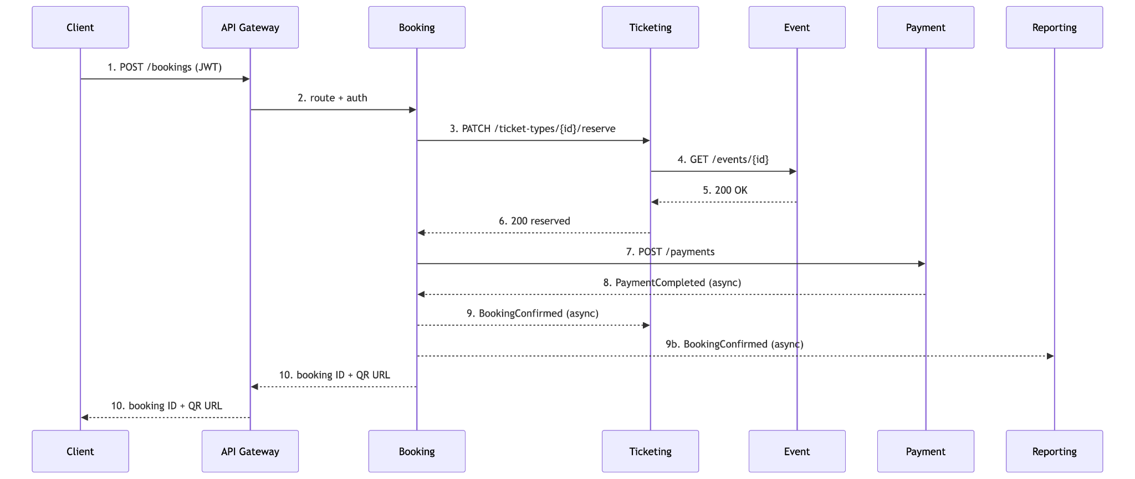

Attendee Check-in Workflow Diagam
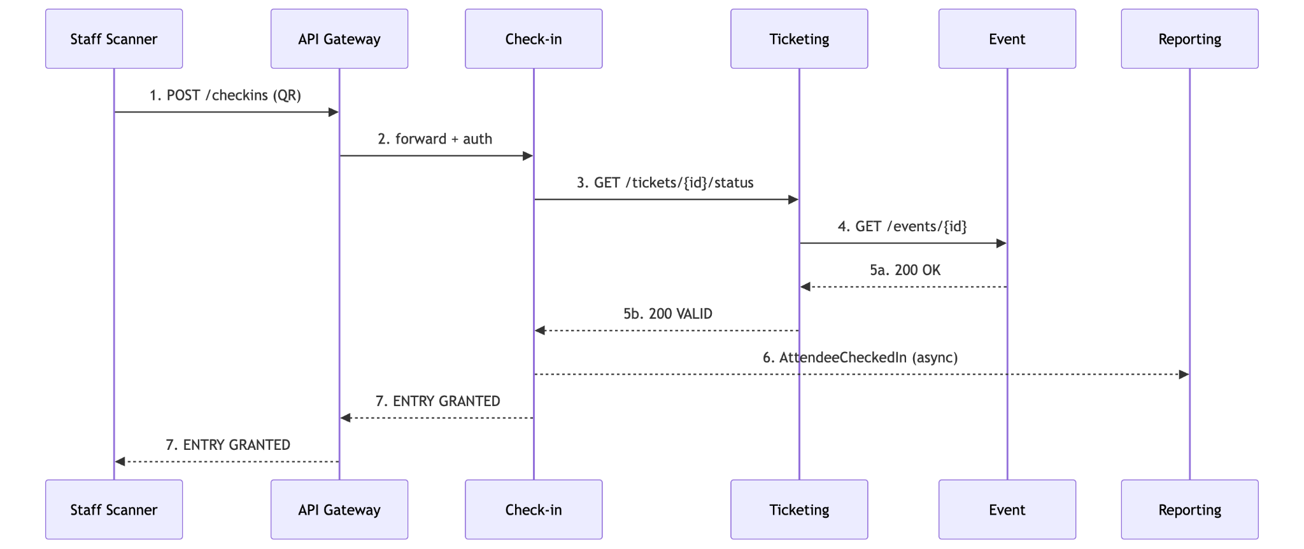

5. Integration Mechanisms

Synchronous: REST calls through the API Gateway for external requests and directly between services for internal calls (e.g. Booking → Ticketing, Check-in → Ticketing). Used when the caller needs an immediate answer.

Asynchronous: Domain events published by producers and delivered to subscribers through an message broker (rebbitMQ). Async events let each service react independently, without slowing down the user.

payment-events | Payment | PaymentCompleted, PaymentFailed
booking-events | Booking | BookingConfirmed, BookingCancelled
checkin-events | Check-in | AttendeeCheckedIn

6. Final Implementation Responsibilities

Two microservices each and the API Gateway is added as a shared team component.

Mohoshena Akhter | Event Management, Venue Management | Event is called by Ticketing and Check-in; Venue is referenced by Event.
Debotush Dam | User, Ticketing | User issues/validates JWTs. Ticketing participates in both workflows (reserve, issue, validate).
Md Parves Shikder | Booking, Payment | Booking drives Workflow 1 and publishes BookingConfirmed / BookingCancelled. Payment publishes PaymentCompleted.
Muhammad Afaq Ali Saqib | Check-in, Reporting & Analytics | Check-in implements Workflow 2 and publishes AttendeeCheckedIn. Reporting consumes events from Booking, Payment and Check-in.
Team (shared) | API Gateway | Single entry point, JWT validation, routing, load balancing.

AI Usage Disclosure: ChatGPT was used to assist with understanding complex concepts, refining wording and grammar, and generating Mermaid code. Mermaid AI was used in the creation of the diagram. These tools were used as learning aids throughout the process. However, the ideas, understanding, and final document reflect our own work.

